Tones, Semitones & New Accidentals!

A SEMITONE is the distance from one key to the very next key (either up or down) with
no key in between. This is ONE step on the keyboard!

A WHOLE TONE is made up of two semitones that are next to each other. There will
always be one key (either white or black) between the notes of a whole tone. These are
always the next line or next space. These are TWO steps on the keyboard!

New Signs:

There are two other accidentals that you should know about:
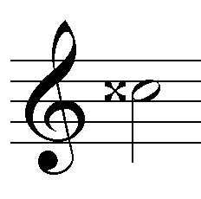

This is a double sharp:

Drawing a double sharp in front of a note raises it TWO semitones (or a whole tone).
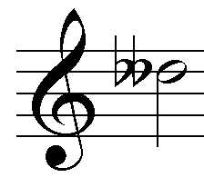
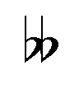
This is a double flat:

Drawing a double flat in front of a note lowers it by two semitones (or one whole tone).

