Cold War USA vs USSR 1945-1991
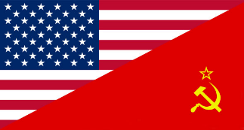
Communism: a political theory derived from Karl Marx, advocating class war and leading to a society in which all property is publicly owned and each person works and is paid according to their abilities and needs.
Capitalism: an economic and political system in which a country's trade and industry are controlled by private owners for profit, rather than by the state.

Dictatorship: a country, government, or the form of government in which absolute power is exercised by a dictator.
Tyranny: oppressive or unjustly severe government on the part of any ruler; undue severity or harshness.

Political Systems:
United States
- Democratic
- Free and fair
- Individual freedoms - if you work hard, you will have $$
Soviet Union
- Totalitarian
- Control of one political party
- The individual works for the benefit of everyone. No rich and poor

Economic Systems:
United States
- Capitalist
- Private Ownership in business and industry
Soviet Union
- Communist
- Businesses owned or control by the state

Key events:
The Yalta Conference – Feb. 1945
Potsdam Conference – July 1945
US bombed Hiroshima & Nagasaki, Japan - Aug 1945
United Nations created 1945
Berlin 1948-1949
North Atlantic Treaty Organization created – 1949
Hungary 1956
Berlin Wall Construction – 1959
Cuba – 1962 (Cuban Missile Crisis)
Vietnam – 1963-75
Czechoslovakia in 1968
Afghanistan 1979-89

